

for
RDM MDM Project

Technical Detail Document (Canvas App with Power Automate Flow)
www.1rivet.com
Washington, D.C. | New York | Toronto | India
Table of Contents
1 Version Control 2
2 Project Information 3
3 Project Introduction 4
4 Architecture/Design canvas app 5
5 Application Workflow & Navigations 6
5.1 Power Automate Flow Execution 7
5.2 List of Data File Assets 10

Version Control

Date | Version | Author | Description of Changes
20-02026 | 1.0.0 | Amresh Prasad | Technical Overview of Canvas Application

Project Information
Project Name | Project Number
RDM MDM
Project Sponsor | System Owner
Project Manager | Technical Project Manager
Architect | Subject Matter Experts
Other Project Stake Holders | Actors – Users, departments, consumers

Project Introduction
- This document provides an overview of the implementation of a Canvas App integrated with Power Automate and SQL Server. It outlines the technical architecture, including the interaction between the Canvas App, Power Automate flows, and the SQL database.
- It also describes how the app is built, including its main features, how each function works, and how data flows between the app, Power Automate, and the SQL database.
- The project dealt with yearly survey Excel files where column names and structures kept changing.
- These changes (new, removed, or renamed columns) caused data upload failures and required a lot of manual checking.
- To fix this, I built a Canvas App that checks the file column structure before processing.
- The app compares the new file with existing schema and highlights differences visually.
- Users can review changes, match old columns with new ones, add missing columns, or choose appropriate data types.
- Before data processing starts, users must confirm the final schema, reducing errors later.
- The solution also maintains logs of who did what (audit logs) and supports bulk updates and historical schema tracking.
- Role-based visuals show different indicators depending on user permissions.
- Power Automate triggers Fabric pipelines to run processing, track execution, and send success/failure notifications.
- Result: less manual work, better control of schema changes, and more reliable ingestion of survey data even when columns change every year.
- The list of canvas application screens is mentioned below:
- Group Table Screen
- Assets Table Screen
- GMS Table Screen
- Schema Registry Edit Details for Kids Count Screen
- Schema Registry Edit Details for Seven files Screen
- Schema Registry Details View Screen
- Deprecated Column Screen
- Audit Log Screen
- Audit Log Detail Screen

Architecture/Design canvas app
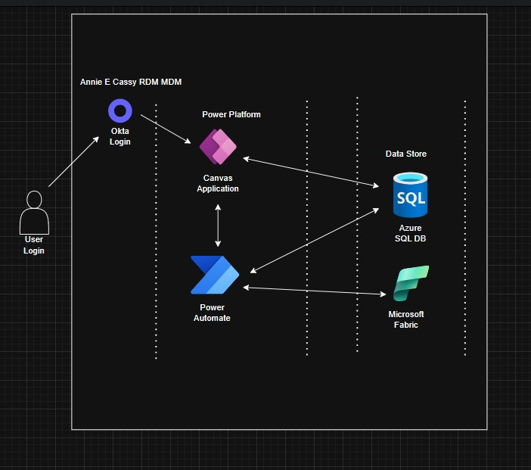
Fig 1; High Level Architecture design of the Canvas Application
- Authentication & Authorization: User login via Okta (federated identity provider) and Conditional access based on identity context.
- Power Apps Canvas: Frontend data interaction layer for business users. Provides validation, execution triggers, and structured data submission flows.
- Power Automate: Middleware orchestration layer between Canvas App and backend platforms. Triggers Microsoft Fabric processing workloads. Captures execution status and returns outcome state to the app.
- Azure Logic Apps: Optional integration layer for external systems or scheduled processing patterns.
- Azure Monitor: Captures operation logs, failures, and performance indicators for Power Automate and Fabric processes.
- Key Vault: Stores API keys, database credentials, and Fabric pipeline auth artifacts. Prevents credential exposure across Power Platform connectors.
- Data Store: Azure SQL Database used as the primary structured data store for transactional, processed, or lookup data. Compatible with Fabric ingestion for downstream warehousing or analytics.
- Third-Party Services: Okta for identity federation. Any additional connectors based on data/business needs.

Application Workflow & Navigations
When the user clicks on "Master Pipeline", the system triggers a Power Automate flow named "Manually Trigger Master Pipeline" in the background. The image below represents the landing page of the Canvas App.
- The records displayed on the List of Groups page are fetched from the SQL database through the configured RDM-MDM SQL connection from the ‘metadata. Group’ table.
- There are two types of records available in the List of Groups section.
  - When the user selects Data Files, the application retrieves data from SQL database to the List of Data File Assets.
  - When the user selects GMS, the application retrieves data from SQL database to the List of GMS Tables.
Note: The overall flow of the Canvas Application is already documented in the User Guide.
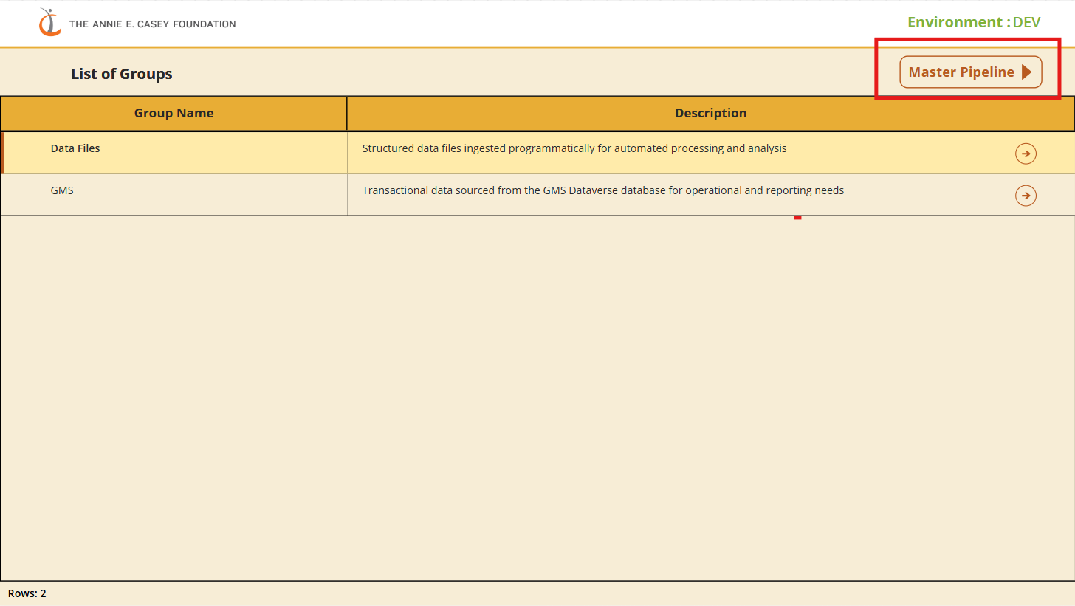
Fig 2; Landing Screen of the Canvas Application

Power Automate Flow Execution
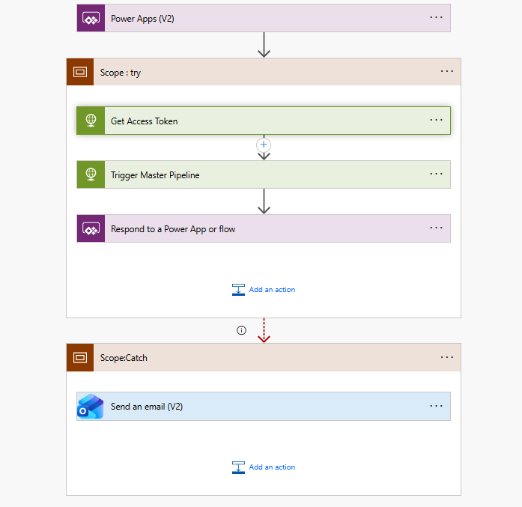
Fig 3; Power Automate Flow when Master Pipeline triggers in the Canvas Application

Step 1: Power Apps (V2) – Inputs: This is the trigger of the flow.
- Purpose: To receive input values from the Power App.
- Inputs
  - Executed By: Receives the username or identifier of the person running the process.
  - To Email: Receives the email address where notifications must be sent.

Step 2: Scope: Try Block: This scope contains the main execution steps (generating access token + triggering pipeline). If anything fails, the Catch block handles the exception.
Action: Get Access Token (HTTP – POST)
- Purpose: To authenticate with Azure AD and retrieve an OAuth 2.0 token.
This token is required to call the Microsoft Fabric API.
- Configuration Method: POST
- URI: https://login.microsoftonline.com/<tenant-id>/oauth2/v2.0/token
- Headers Content-Type: application/x-www-form-urlencoded
- Body Parameters: Sent using standard OAuth 2.0 client_credentials format:
ClientID=<client-id>
scope=https://api.fabric.microsoft.com/.default
client_secret=<client-secret>
grant_type=client_credentials
- Explanation of Each Parameter:
- client_id: Unique ID of the Azure App Registration.
- client secret: Secret key generated inside Azure App Registration.
- Scope: Defines what API the token can call; here it is Fabric API.
- grant_type = client_credentials: Flow used for backend authentication without user login.
- Output: Returns JSON containing: access_token (used in next API call)

Action: Trigger Master Pipeline (HTTP – POST)
- Purpose: To call the Microsoft Fabric Pipeline API and start a Master Pipeline execution.
- Configuration Method: POST
- URI: https://api.fabric.microsoft.com/v1/workspaces/<workspace-id>/items/<pipeline-id>/jobs/instances?jobType=Pipeline
- Headers Authorization:
  - Bearer <access_token>
  - Token taken from the Get Access Token step (Body('Get Access Token')?['access_token'])
- Body (JSON): This sends pipeline execution details:
{
"type": "PipelineRun",
"executionData": {
"parameters": {
"ExecutedBy": "@{triggerBody()['ExecutedBy']}",
"DBConnectionString": "@{variables('DBConnectionString')}",
"ExecutionType": "On Demand",
"ToEmail": "@{triggerBody()['ToEmail']}"
}
}
}
- Explanation of Fields
  - type: "Pipeline Run": Specifies this is a pipeline execution.
  - execution Data → parameters: Sends dynamic values to the pipeline:
    - ExecutedBy: Person triggering the pipeline.
    - DBConnectionString: Passed database connection string.
    - ExecutionType: Hardcoded as "On Demand".
    - ToEmail: For sending notification emails.
- Output: Returns API response including:
- HTTP Status Code
- Pipeline Run ID (if successful)

Action Respond to a Power App or Flow
- Purpose: Send the response back to Power Apps.
- Output
  - Field: status
  - Value: Status code returned by the Master Pipeline API.
This allows Power Apps to evaluate if: The run was successful, or it failed.

Step 3: Scope: Catch Block: This runs only when the Try block fails.
Action: Send an Email (V2)
- Purpose: Notify team members if any failure occurs in:
- Access token generation
- Pipeline trigger
- Any step inside the Try Scope
- Configuration: ToEmail received from Power Apps.
- Subject: Clearly states failure: Power Apps Flow Failure Notification – Manually Trigger Master Pipeline
- Body Includes: A message that the flow failed.

List of Data File Assets

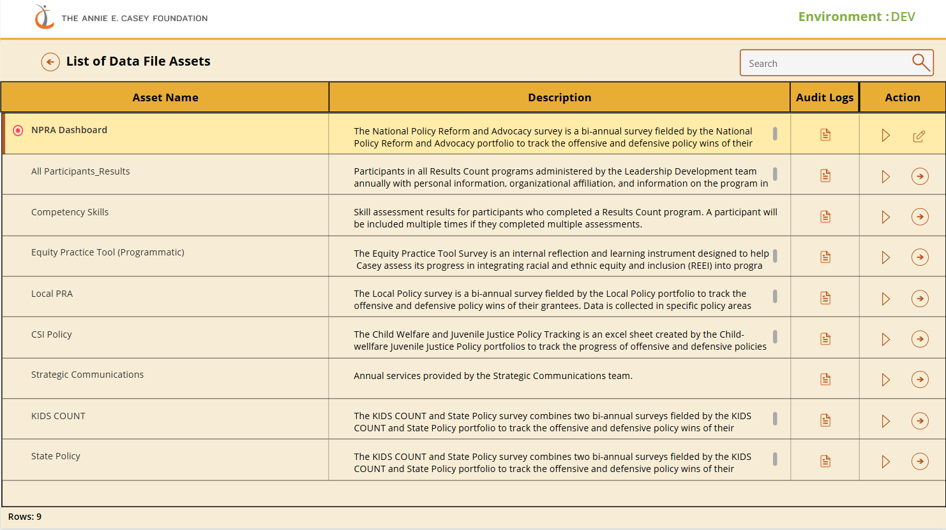
Fig 4; List of Data Assets Screen in the Canvas Application
- The List of Data File Assets screen displays a grid of available data assets along with key details such as Asset Name, Description, Audit Logs, and an Action column.
- Clicking the Action Item button triggers an automated Power Automate flow that starts the Microsoft Fabric Pipeline for backfilling Giles and GMS datasets.
- Upon clicking the Edit icon in the Action column, the application fetches the relevant data from the metadata.schemaregistry table and renders it on the subsequent screen. Upon navigation, the application presents two distinct sections:
    - Ingestion Layer Schema State Details: fetched directly from the table & listed down.
    - Verification of New Schema Changes: fetched by filtered the records.
On Confirm click, the app first validates duplicate target logical names and datatype specific default values, groups all detected errors, generates an HTML formatted validation summary, and then displays either an error popup or proceeds with the confirmation.
After successful validation, the Confirm action triggers a stored procedure to finalize the schema update & marking it verified, updating schema records, refreshing related data sources, sending a schema reviewed notification, and finally navigating the user to the updated schema details screen.
- Upon clicking the View icon in the Action column, the application fetches the relevant data from the metadata.schemaregistry table and renders it on the subsequent screen.
- Clicking on the document icon under the Audit logs column, it will fetch the details of the Audit from the ‘metadata.schemaregistry’ table. It is implemented by using power FX collection concept.
- The Action Item button invokes a Power Automate (PA) flow named: “Fabric Pipeline Trigger for Backfilling files and GMS”
- The flow runs in the background without requiring any further user input.
- Trigger Mechanism: Each Action Item button passes relevant asset metadata (such as Asset ID or Asset Name) to the PA flow.
- Below is a high-level breakdown of how the Power Automate workflow executes the pipeline:

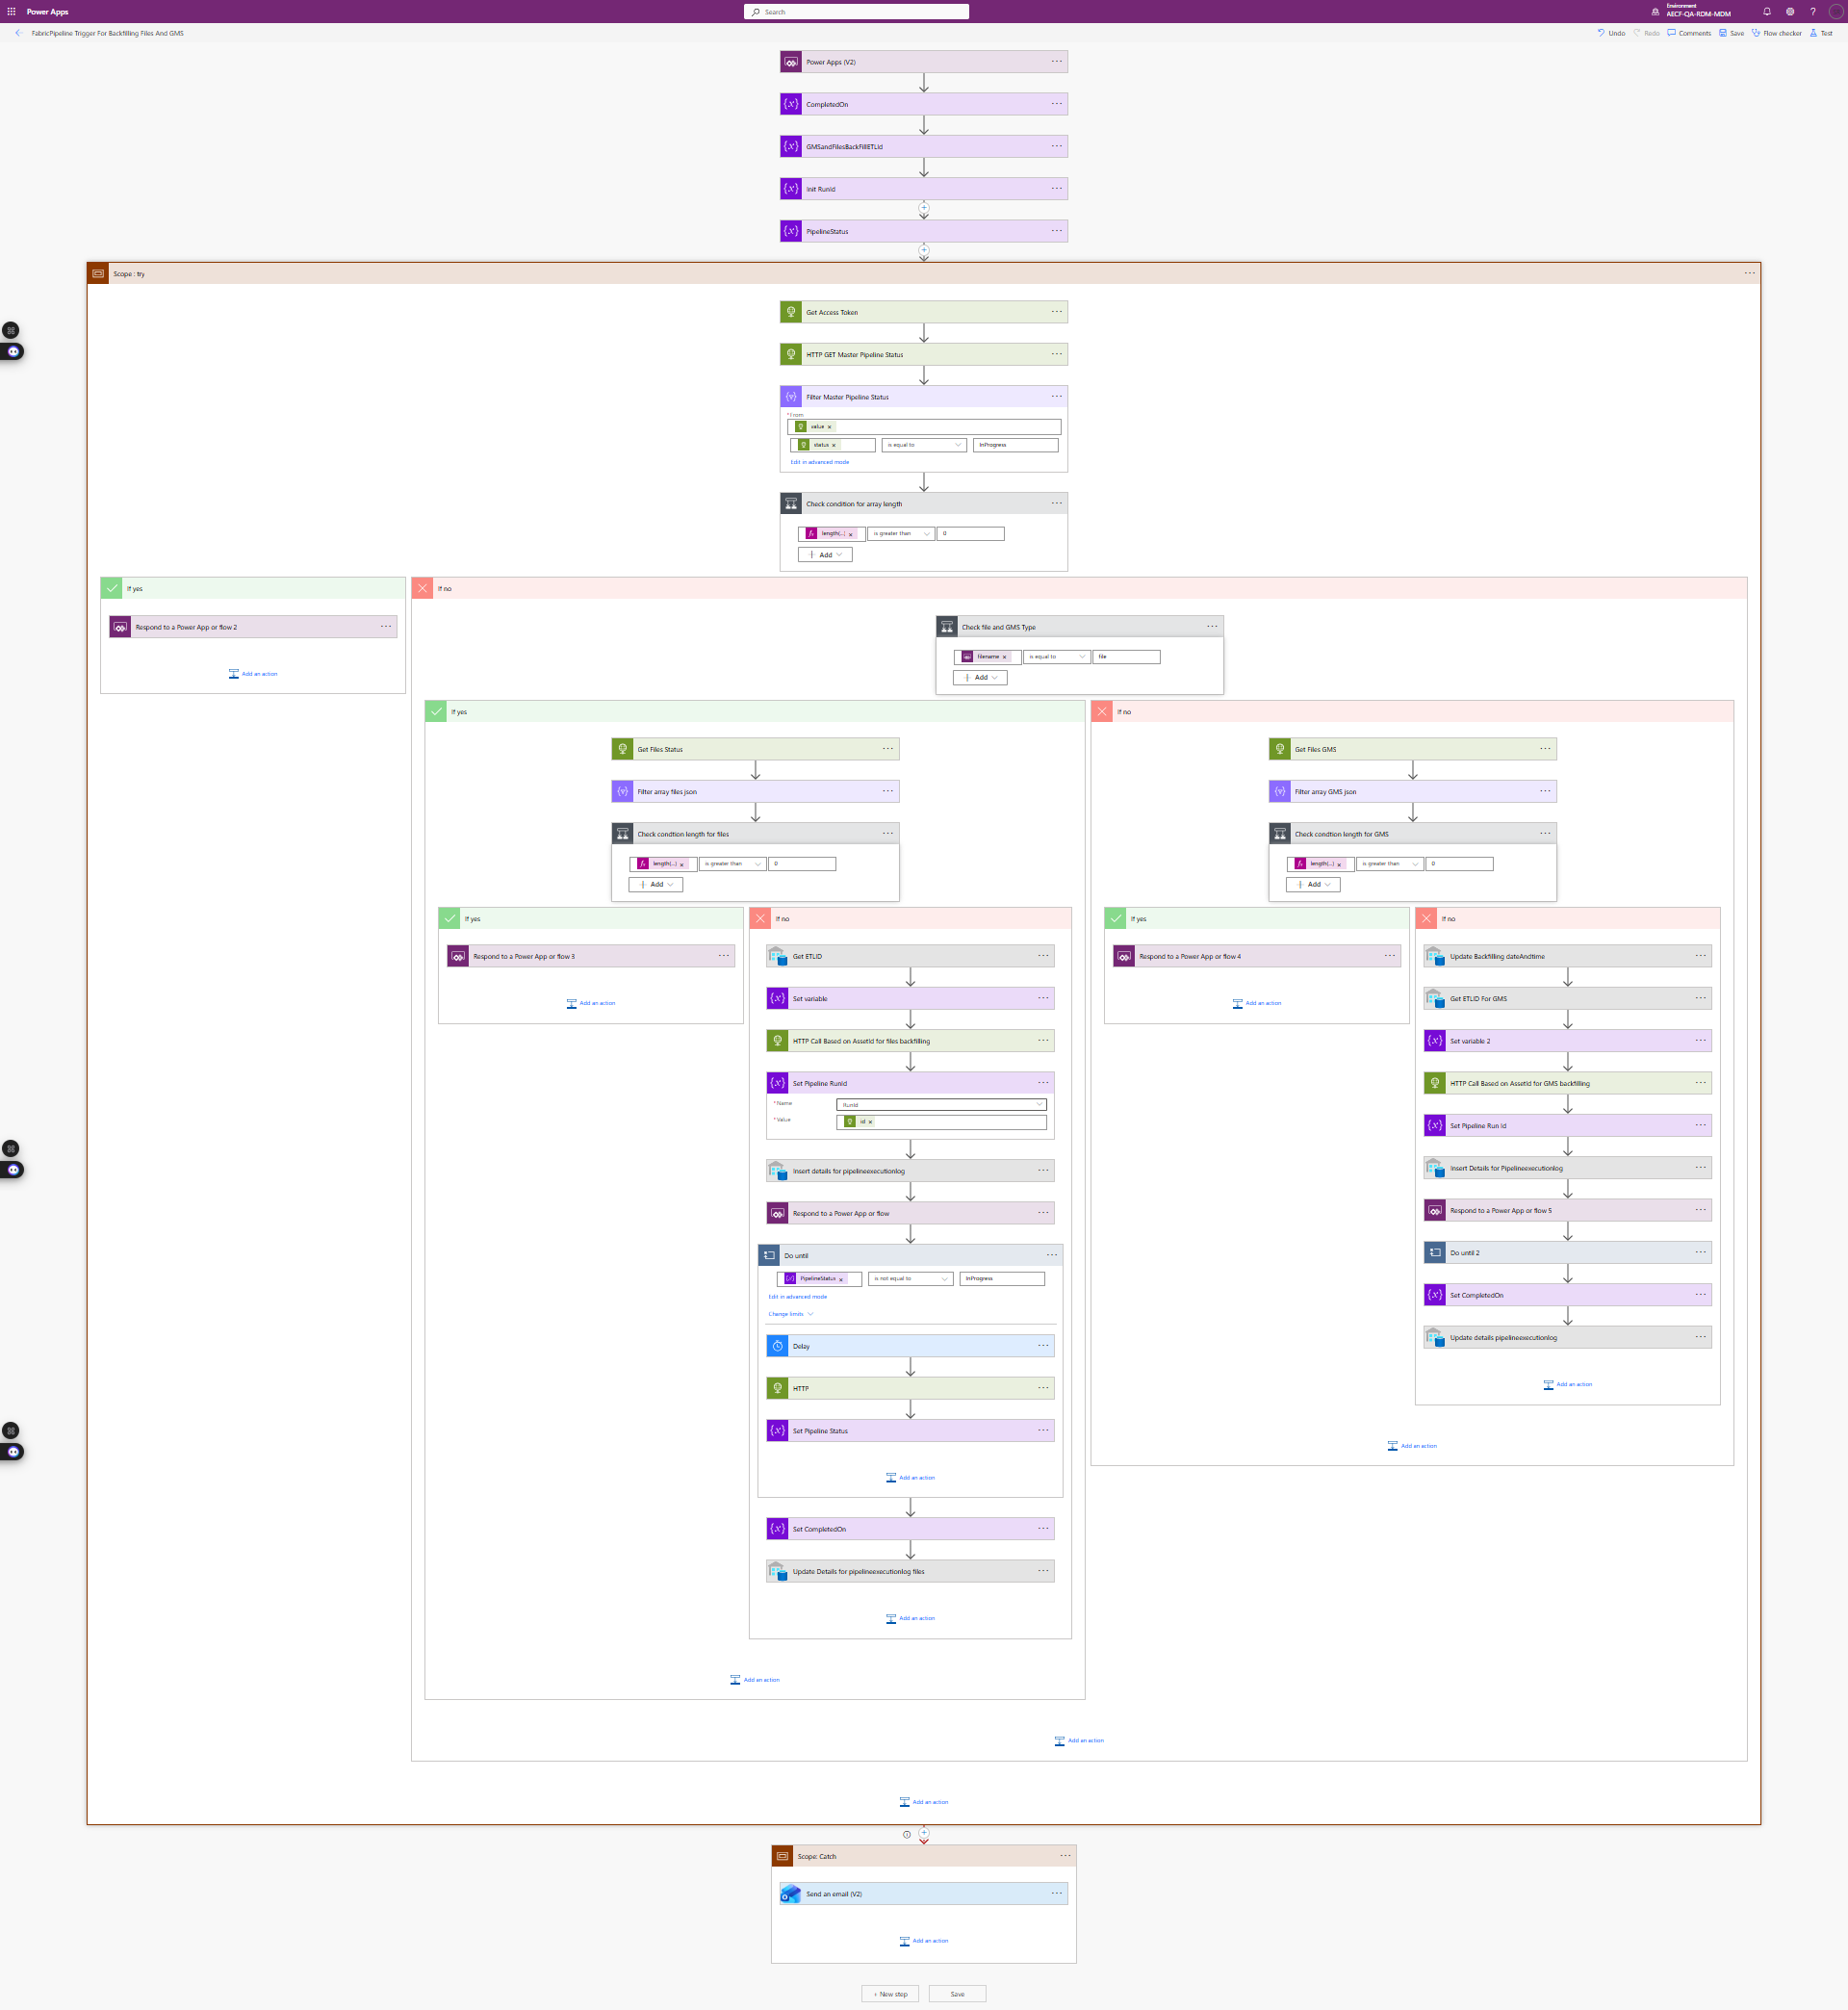
Fig 5; Power Automate flow execution flow of Fabric Pipeline Trigger for Backfilling Giles and GMS
STEP 1 — Inputs from Power Apps(v2)
- You are receiving inputs such as:
- AssetId
- ExecutedBy
- idf_pipelineIdInput
- GMSBackfillDate
- FilesBackfillDate
- StartedOn
- filename
- ToEmail
- Assetname

- These input fields are used later for:
- calling pipelines
- logging
- email messages
- SQL insert/update

STEP 2 — Initialize Variables
- You initialize variables:
- Completed on
- GMSandFilesBackFillETLId
- RunId
- PipelineStatus
- These variables will store:
- when pipeline finished
- ETL ID
- pipeline run ID
- live status of pipeline

STEP 3 — Get Access Token
- You call: POST https://login.microsoftonline.com/{tenant}/oauth2/v2.0/token
- Body contains:
- client_id
- client_secret
- scope = Fabric API
- grant_type = client_credentials
- This provides a Bearer Token ‑ required for all Fabric API calls

STEP 4 — CHECK MASTER PIPELINE STATUS
- API call: GET https://api.fabric.microsoft.com/v1/workspaces/{id}/items/{MasterPipeline}/jobs/instances
- You filter returned array where: status = "InProgress"
- Then check: length (filtered array) > 0 ?

If YES → A pipeline is already running Flow returns response to Power Apps: “Pipeline already running”
If NO → Continue to FILE/GMS check

STEP 5 — Check FILES or GMS pipeline based on input
- You have a condition “Check file and GMS type”
- If FILES: You call the file pipeline jobs list and filter:
      - status = "InProgress"
      - Same logic:
- if in progress → stop
- if not → continue
- If GMS: Same logic but using GMS pipeline

STEP 6 — IF no pipeline running → Get ETL ID
- You run an SQL query:
SELECT Coalesce(Max(ETLId)+1,1)
FROM AuditPipelineExecutionLog
WHERE ExecutionType='On Demand'
AND MasterPipelineRunId IS NULL
- Purpose: Generate new ETL ID (auto‑increment style)

STEP 7 — Start the ETL Pipeline
- HTTP POST: POST /items/{Pipeline Files}/jobs/instances?api-version=2023-02-01
- Body sends: JSON
{
"type": "PipelineRun",
"executionData": {
"parameters": {
"AssetId": asset_id,
"idf_pipelineId": idf_pipelineIdInput,
"ExecutedBy": ExecutedBy,
"ETLId": GMSandFilesBackFillETLId, } } }
- The response gives you: runId
- You store this in variable RunId.

STEP 8 — Insert LOG into SQL Table
- SQL Insert: INSERT INTO AuditPipelineExecutionLog (RunId, filename, status, startedon, triggeredby, completedon, assetname)
- This logs:
- pipeline run id
- who triggered
- when it started
- status = "Running"

STEP 9 — Respond to Power Apps
- You send the RunId or status back to the app. This happens early so the app does not wait for long polling.

STEP 10 — DO UNTIL loop (Pipeline Status Polling)
- Loop condition: PipelineStatus is not equal to 'InProgress'
- Inside loop:
- Delay 1 minute
- GET pipeline status (Fabric API)
- Update variable PipelineStatus
- This repeats until pipeline is:
- Succeeded
- Failed
- Canceled

STEP 11 — Set CompletedOn
- After pipeline finishes: CompletedOn = utcNow()

STEP 12 — SQL Update Final Log
- You update database:
UPDATE AuditPipelineExecutionLog
SET status = {PipelineStatus},
completedon = {CompletedOn}
WHERE RunId = {RunId}
- So that: Final status stored - Completion time logged

STEP 13 — SCOPE CATCH (Error Handling)
- If ANYTHING fails: You send an email:
To: to email
Subject: Pipeline Failure Notification
Body: Includes:
- RunId
- filename
- DateTime
- With Link

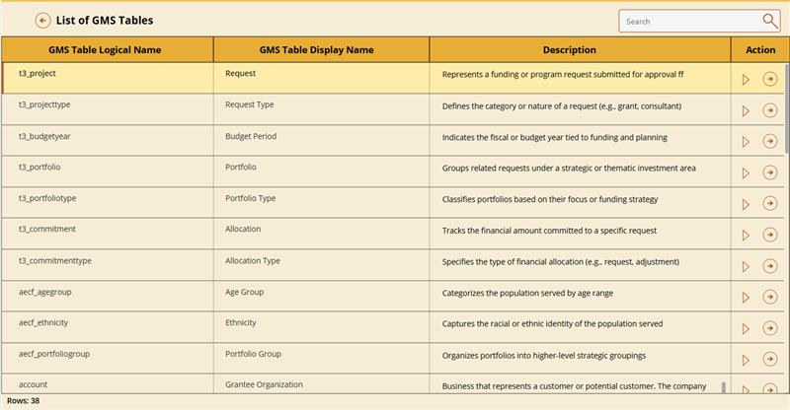
Fig 7 ; Screen of List of GMS Tables in the Canvas Application

- The table records displayed on this screen are dynamically retrieved from the metadata.assets table by filtering on the selected groupid.
- Upon clicking the ‘arrow’ icon in the Action column, the application fetches the relevant data from the metadata. Assets table and render it on the subsequent screen based on the selected assetid. Upon navigation, the application presents two distinct sections
    - GMS Table Schema State: The system retrieves the latest schema record for the selected asset by filtering the metadata.schemaregistry table by assetid and sorting by createddate in descending order. It then extracts and parses the associated schema JSON, converting it into a structured collection with properly mapped fields and formatted dates. A working dataset is created, including an IsNew flag to highlight newly added schema entries, which are sorted to appear first. Finally, a duplicate copy of the processed collection is stored in colCountGMSDetails for counting and additional operations without modifying the main dataset.

    - Deprecated Columns: The screen retrieves all records from the metadata.GMSDeprecated table where assetid = varGMSAssetId. These records are then sorted in descending order based on the createddate field, ensuring the most recently created entries appear first. The sorted dataset is stored in the colGMSDeprecatedDetails collection for display and processing. A secondary copy, colCountGMSDeprecatedDetails, is created to support counting and additional operations without modifying the original collection.

- Clicking the Action Item button triggers an automated Power Automate flow that starts the Microsoft Fabric Pipeline for backfilling Giles and GMS datasets
When “file or GMS type” condition → equals GMS

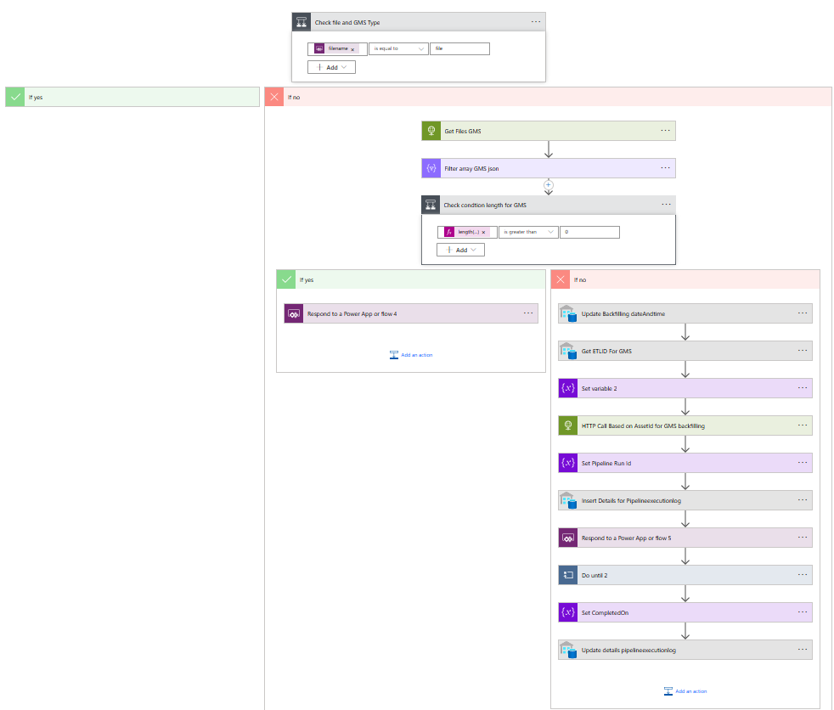
Fig 8 ; Power Automate flow steps for triggering the GMS Pipeline

STEP 1 : Check GMS Pipeline Running
- Get Files GMS
- Your flow calls:
- GET:https://api.fabric.microsoft.com/v1/workspaces/{id}/items/{GMSPipelineId}/jobs/instances
- This returns all GMS pipeline execution instances.

STEP 2: Filter Only InProgress Runs
- A Filter Array checks:
- status = "InProgress"
- If any run is in progress → you stop and return a response to Power Apps.

STEP 3: Check GMS Array Length
- Condition: length(filtered array) > 0 ?
- If YES → return to Power Apps (pipeline busy)
- If NO → continue with GMS backfilling process

STEP 4: Update Backfilling Date in Database
- SQL Query:
UPDATE metasds.assets
SET lastexecutiondate = CAST(@GMSBackfillDate AS DATETIME)
WHERE assetid = @assetid
OR EXISTS ( complex condition using STRING_SPLIT )
- Purpose: Store the GMS backfill date for this asset before executing the run.

STEP 5 : Get ETL ID for GMS
- SQL query:
Select Coalesce (Max(ETLId)+1,1) as GMSandFilesBackFillETLId
from AuditPipelineExecutionLog
where Execution Type = 'On Demand'
and groupid = 2
and MasterPipelineRunId IS NULL
- This generates a new ETL ID for this GMS run.

STEP 6 : Set Variable: GMSandFilesBackFillETLId
- You store the SQL result into a variable for using inside pipeline JSON body.

STEP 7 : HTTP CALL → Trigger GMS backfilling Pipeline
- POST request: https://api.fabric.microsoft.com/v1/workspaces/{workspace}/items/{GMSPipelineId}/jobs/instances?api-version=2023-02-01
- Body includes: JSON
{
"type": "PipelineRun",
"executionData": {
"parameters": {
"AssetId": asset_id,
"idf_pipelineId": idf_pipelineIdInput,
"ExecuteBy": ExecutedBy,
"ETLId": GMSandFilesBackFillETLId } } }
- Fabric responds with: "runId": "<PipelineRunId>"

STEP 8 : Set Pipeline RunId
- You store the returned runId in a variable called: RunId

STEP 9 : Insert Initial Log into SQL Table
- SQL Insert:
INSERT INTO AuditPipelineExecutionLog
RunId,
filename,
status,
startedon,
triggeredby,
completedon,
- This logs to the start of the GMS backfill execution.

STEP 10 : Respond to Power Apps (Early)
- You send back: status: 200
- Purpose: Power Apps doesn’t wait for long polling. Flow continues in background.

STEP 11 : DO UNTIL LOOP (Poll for GMS Pipeline Status)
- Loop condition: Pipeline Status != 'InProgress'
- Inside loop: Delay 2 minutes: To prevent hitting API rate limits.
- GET Status of Pipeline Run GET:https://api.fabric.microsoft.com/v1/workspaces/{id}/items/{GMSPipelineId}/jobs/instances/{RunId}
- You extract status → Succeeded / Failed / Canceled / InProgress
- Set Pipeline Status variable
- Set variable: Pipeline Status = response. Status
- Loop until NOT InProgress

STEP 12: Set Completed On Timestamp
- Completed On = utcNow()

STEP 13: UPDATE Final Log in SQL
- SQL update:
UPDATE AuditPipelineExecutionLog
SET
status = @PipelineStatus,
completedon = @CompletedOn
WHERE RunId = @RunId
Step 14: SCOPE CATCH (Error Handling)
- send email for power automate fails

